Morgan Shively

*Social Unrest Indicator Application*

**Part 1: Application to Ferguson, St Louis, Missouri**

*Ferguson, St Louis – Original Words*

*Ferguson, St Louis – Revised Words*

After mapping my initial words there were a lot of spikes in the graph however none of them stood out in particular in terms of relevancy to the unrest in Ferguson. On the first graph I can see that there is an increase in social unrest around point 90 (circled in red) which is the first week of August in 2014 however, there were other peeks in the first graph that appeared which were in fact higher that were not representative of that particular case of social unrest we were looking for. I choose to remove some of the words that were indicative of social unrest in order to attempt to increase the peak around the first week of august. After doing so, I selected new words from the network I believed would have appeared in higher frequency around the time of the Ferguson Riots. The words that were removed after the mapping of the initial data were: terrorist, virulent, feeling, and home. While initially I felt that these words might be indicative of negative sentiment they did not have an inherent connection with the Ferguson riots in terms of an increase in their frequency during that time. After the removal of these words, they were replaced with a new set which are respectively: police, gunshot, law, and crime. After incorporating these words the highest peak on my graph (also circled in red) appeared directly on August 9th 2014 at point 90, and then a second highest peak on my graph at point 104 which corresponds to late November of 2014 when the second wave of riots occurred. My new words police, gunshot, law, and crime were all also relative to my remaining original words which I believed were related to social unrest. I chose these four words because they were also prevalent in the negative word network consisting of the words like “die, murder, and power”. Considering the riots that were happening in Ferguson as a result of police killings, it seemed only natural whenever people were searching for terms like as power and law, or crime and death, they would also be using terminology relative to that of police violence. Even more so, I felt that logically these networks would correspond with each other in that police violence was one of the main factors in the Ferguson riots to begin with. After much deliberation about selecting proper words I was able to peeks on my graphs pertinent to that of the Ferguson unrest.

**Part 2: Application to Regions of Unrest and Calm**

Due to the fact that I had success with my revised set of words for the riots in Ferguson I decided that I would apply my social unrest indicator to other regions of the United States that experienced unrest as a result of police violence and brutality, name places that where main stream police killings took place.

These five graphs represent five different police related murders of allegedly innocent people. With that being said we can see where spikes in words related to murder, crime, and killings appear at the times where these occurrences took place. Presumably we can say that this is a public response therefor generating the increase of frequencies of these words.

Next I did research in order to create a list of five more regions in the Unites States that supposedly have a high quality of life for its general population. I also made sure that these regions were densely populated enough so that the sample size was legitimate when examining them at stages of social calm.

Graphs Representing Places of Social Calm

The two graphs here that I think represent the best application of the social unrest indicator are Omaha, Nebraska and Des Moines, Iowa. Briefly looking into these two cities it is said that they generally share three qualities that make them considered as peaceful places to live in, namely these can be seen as low cost of living, low unemployment rate, and low crime rate. These three qualities tend to be reoccurring in cities that experience social calmness consistently, excluding outlying events that can be considered anomalies.

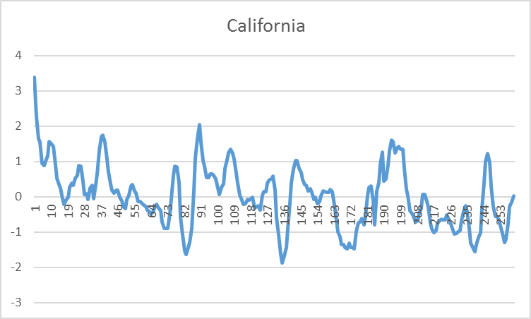**Part 3: Application to States**